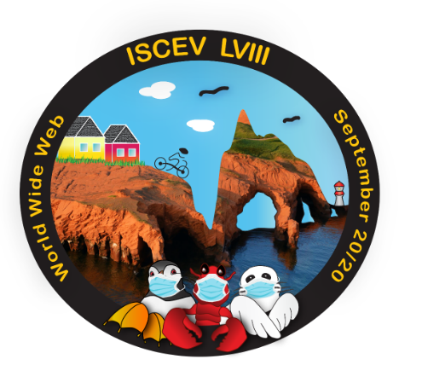

**ISCEV LVIII VIRTUAL OLYMPICS ACTIVITIES**

**This year’s ISCEV Olympics have also adapted to the virtual format, with a range of different competitions that will enable your team to win this year’s virtual Olympics Trophy!**

**Below please find the 4 selected activities:**

PAST ISCEV PHOTO CONTEST

Your team is requested to select up to 5 most memorable or “funny” pictures of past ISCEV conferences. A short caption should be attached to each chosen photograph (including the ISCEV year and location). These pictures will then be showcased (anonymously) on our website, where this year’s participants (registered and non-registered members) will be asked to vote for 3 favorite pictures! Winners will be announced at the closing ceremony.

*You can send these pictures as of today to* info@iscev2020.ca

PAST ISCEV GIFT GUESSING COMPETITION

A set of past ISCEV gifts can be found in the attached pdf file. Your goal will be to correctly identify these gifts to their corresponding ISCEV meeting, but be careful… not all items were actual gifts of past symposiums and some meetings gave multiple gifts! Please write your team’s answers on the corresponding answer form (one form per team).

VIRTUAL TREASURE HUNT

A treasure hunt related to ISCEV’s history will be available shortly on our website (*iscev2020.org*) which will bring you to the treasure. Your team’s mission is to find all the correct answers and send us the resulting screen shot of your treasure!

ISCEV OLYMPICS TALENT SHOW

In the more social spirit of ISCEV, all members of the Olympic team will be asked to participate in the creation of an ISCEV song. Teams are invited to create and record a song with associated choreography, using the platform of their choice (Zoom, Skype, etc.). Your video (max 2-3minutes duration) will have to be submitted before *September 12th* (at info@iscev2020.ca). Here are the specific requirements that need to be in your video:

* Imposed words are ISCEV, ERG, COVID, virtual, Îles-de-la-Madeleine
* Must have a choreography
* At least one instrument per group must be played during the song
* Extra points for the number of participants (i.e. bigger groups = more points) and originality